**Analysis of Mass Shooting in Chicago, Illinois**

Analysis of mass shooting considering gun violence for Chicago, Illinois

Mithila Nigudkar

Information Science and Technologies

Rochester Institute of Technology

Rochester, NY, USA

[Mn7646@g.rit.edu](mailto:Mn7646@g.rit.edu)

**ABSTRACT**

*Gun related savagery is one of the most squeezing law enforcement issues in America [4]. It can be noticed that 2019 had the highest number of mass shooting in any year since 2014. Gun violence in the United States is a significant issue and it is critical to go to lengths and structure techniques in advance particularly in regions where the possibilities of this reoccurring are exceptionally high. To sort that out we really want to observe replies to questions like, which are the areas generally impacted by mass shootings and firearm viciousness as far as number of individuals killed and harmed? What sort of impact did it have on the populace? associated with terms of number of setbacks (killings in addition to wounds), connecting with the quantity of weapons utilized in gun violence incidents in the area? Is there a requirement for more control assets like police stations and medical clinics in such a locale? How effectively would we be able to utilize Geographic Information Systems to make clearing based directing methodologies to local crisis benefits in advance in the event of all the more such occurrences. Responding to these inquiries by taking a gander at the occurrences at a theoretical level in the country too. Information on the gun violence in the United States was acquired from The Gun Violence Archive (GVA) [1] and source from an open-source GitHub archive [2]. The information was accessible as a tar document. It contained the information in (.CSV) design. The information comprised of gun violence from 2013 to 2018. This information was brought into the ArcGIS pro. It contained 239,677 records. It had fields for date, number of killings, number of individuals harmed, number of guns utilized in an episode, and so forth.*

*The focus was on Chicago. Heat map is constructed for the regions where there is a very high possibility that the city might be affected by gun violence. Number of weapons used in the attacks were calculated. For this proposal the study considered was where in a school was attacked and there was a need for emergency and the school needed to be vacant and the students and the professors had to be moved to the nearest emergency location available. Through this study we can see how GIS is useful for making strategic decisions.*

**Keywords:** Gun Violence, Mass shooting, Heat Map, Weapons.

1. **Introduction**

[1] According to an article published there have been an increase in the number of gun violence in the past few years. There were no precautionary measures that were taken to tackle this situation which has worsen the situation. The amount of money spend on such circumstances is very high. And the percent is still increasing. Therefore, it is very important to increase the resources and develop better strategies.

1. **Problem Statement**

This study focuses on gun violence in America to drive into deeper the main area of focus is Chicago, Illinois. In deal with this scenario is it very important to find the answers to the questions like, which area is widely affected? How many casualties are there? Does the area affected needs more security? Number of people killed? Number of people affected? How will GIS help us to improve and to make sure we can take future precautionary measures. So that such violence can be prevented beforehand.

1. **Goal and Objectives**

The focus on this analysis was to track down replies to the inquiries referenced in the problem description alongside making situation-based departure directing plans in a specific region in the country (for our situation that being Central Chicago Area, Illinois) lastly visualize the outcomes got through maps utilizing cartographic standards. The following objectives have been used to accomplish goals.

1. Using hotspot analysis, determine which regions are the most affected in terms of the number of people dead and injured.
2. Create a heat map for a chosen region (Chicago, Illinois) and select a subarea to investigate (Central Chicago Area, Illinois).
3. Using mapping tools, justify the necessity for more control resources such as hospitals and police stations.
4. To compare and depict the relationship between the number of casualties and the number ofweapons engaged in gun violence episodes in the given location, use proportional symbols**.**
5. Using a scenario (in our example, a school in distress owing to gun violence in the neighborhood) and Routing in Network Analysis, demonstrate the usefulness of GIS developing emergency based routing strategies to hospitals and police stations in ArcGIS pro.
6. **Literature Review**

In a paper on "GIS Crime Mapping to Support Evidence-Based Arrangements [5]", it's said that Geographic Information Systems (GIS) can be utilized successfully in making proof based arrangements like referenced in the article on GIS Crime Mapping [5].In the paper, the creators centre focus was the ID of spatial patterns in weapon related violations during 2012 to 2017, alongside recognizing designs when the presentation of safe entry courses in four regions in Chicago they concentrated about [5]. Their concentrate on uncovered that area of interest patterns for weapon related violations have heightened in the majority of the networks around there, which incorporate school zones and safe section courses [5]In one more article about "The Philadelphia Foot Patrol Experiment [6]", the outcomes showed the viable commitment of areas of interest in place‐based policing bringing about decrease of crime, and particularly violent crime, which is a huge general wellbeing danger in the US [6].

1. **Datasets**

**5.1 Data Pre-processing**

Information on the gun violence in the United States was acquired from The GunViolence Archive (GVA) [1] and source from an open-source GitHub archive [2]. The information was accessible as a tar document. It contained the information in (.CSV) design. The information comprised of gun violence from 2013 to 2018. This information was brought into the ArcGIS project. It contained 239,677 records. It had fields for date, number of killings, number of individuals harmed, number of guns utilized in an episode, and so forth.

ArcGIS pro was used to analyze the results. Different tools like select by location, select by area were used and added to the project as a feature layer. It became easy to visualize data with the help of ArcGIS pro.

**5.2 Methodology**

**5.2.1 Heat Map**

By using heat map, it is possible to show how the data is distributed. Heat maps are generally made to envision the focus examples of geographic information utilizing the thickness examination of point or polyline information. A heat map utilizes shading slope to show and demonstrate the geographic thickness dispersion across an area. [8] Heat map works the best when the symbols overlap, majorly when there is a large number of features available.

[8] Heat map symbology shows the overall thickness of focuses as a unique raster perception utilizing a shading plan to demonstrate thickness values. Preferably, the shading plan is an easily changing arrangement of tones, going from cool (inadequate thickness of focuses) to hot (high thickness of focuses). The thickness definition, and along these lines the shading values, change as you zoom in and out. The thickness is determined utilizing the piece thickness strategy, a similar calculation utilized by the Kernel Density geoprocessing instrument.

**5.2.3 Hotspot Analysis**

[7] For each feature in a dataset the hotspot analysis measures the Getis-Ord Gi*. The results that were obtained from the p-values and z-scores will give us an idea about the total number of casualties in Chicago and the areas that were damaged due to the gun violence.

1. **Outcome obtained**

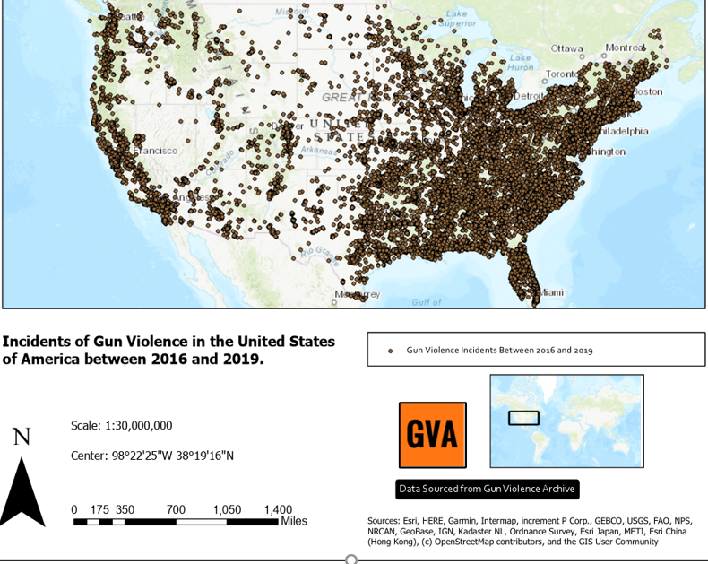

**Figure 1: Mass shooting in United States from 2-15-2018**

The above figure displays mass shooting such as gun violence in the United States. The data used above was obtained from GitHub.

* 1. **Hotspot Analysis**

Further, hotspot analysis was conducted to determine the number the number of people who were injured and also killed during the gun violence. From the figure below (figure2) it is evident that Southern California and Eastern America had the massive number of killings. The number of

People injured was considered as input.

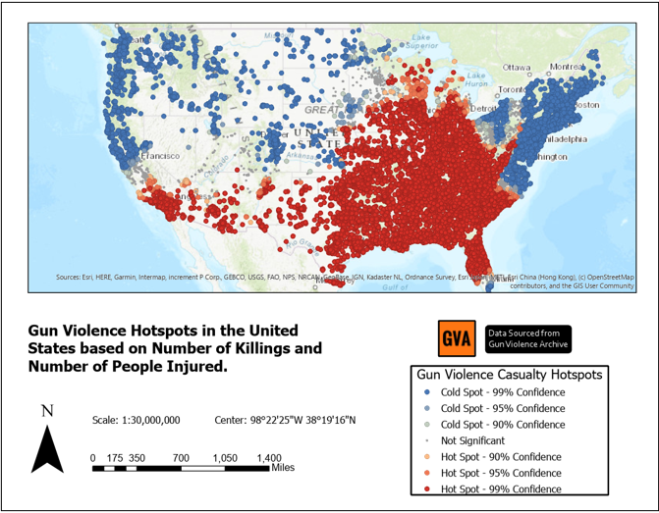

**Figure 2: Hotspot Analysis of Gun Violence.**

* 1. **Heat Mapping of Gun Violence.**

After conducting the hotspot analysis, the next step was the heat mapping. From the figure 2 we can see the regions that were affected due to the gun violence. Later Chicago, Illinois was selected as the region for conducting this study.

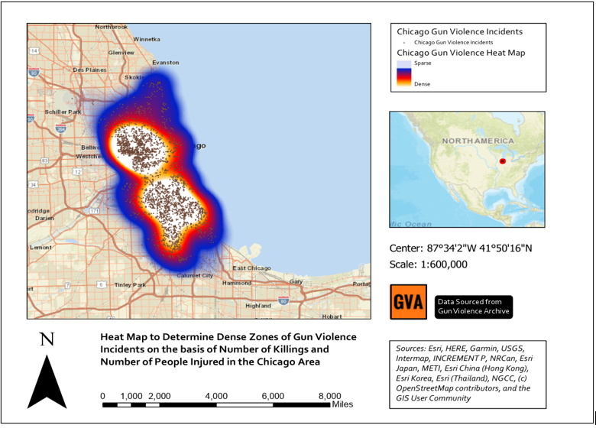

**Figure 3: Heat Map based on gun violence in Chicago.**

* 1. **Emergency control for a school under attack.**

As mentioned, a school under attack was considered to show how we can use GIS to show and handle emergency situations, where in we look for help nearby, considering the nearby police stations or hospitals.

As there as was continuous gun violence in that area. The school which was under attack was supposed to transfer the children safely to the nearby safe house or the emergency locations that were available.

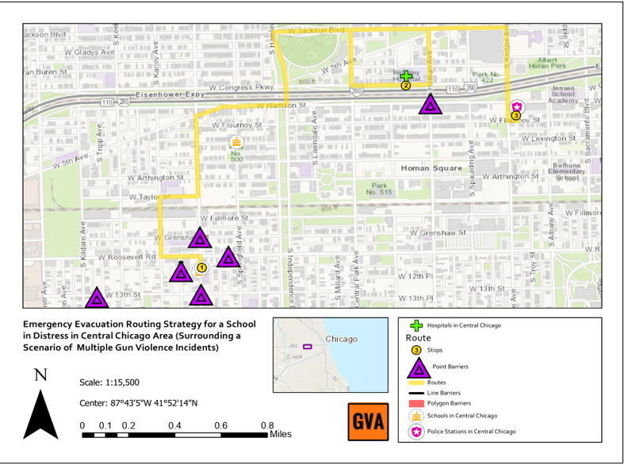

**Figure 4: School under attack.**

1. **CONSLUSION**

GIS can be we very useful in such analysis that will help to control such events in the future. The data used for this analysis was found on open-source GitHub [2]. Data available needed some pre-processing which was done in ArcGIS pro. By doing this analysis we found out the high-risk zone areas and conducted an analysis on it. A school under attack was considered to give a better understanding of how does the GIS works. The same process can be repeated depending on the different datasets that one would like to explore. This study has given us a nice idea of the gun violence in Chicago.

1. **FUTURE WORK**

The future work for this analysis would be we can consider the gun violence depending on different categories such as number of weapons used, age group that has maximum number of casualties or maximum number of people injured, we can also consider gender. Also, we can we have a look at when are the greatest number of gun violence’s are taking place. What time of day it is? Which kind of gun is usually used? And we can perform an analysis based on this different category.

1. **REFERENCES**

[1] Anon. Gun Violence Archive. Retrieved March 1, 2020 from https://www.gunviolencearchive.org/

[2] Anon. jamesqo - Overview. Retrieved March 1, 2020 from <https://github.com/jamesqo/>

[3] Nirbhay Ashok Pherwani. 2019. Analyzing H7N9 and H5N1 Influenza Cases. (October 2019). Retrieved March 1, 2020 from https://github.com/nirbhayph/Geographic-Information-Sciences-and-Technologies-RIT/blob/master/Week 7/Analyzing H7N9 and H5N1 Influenza Cases.pdf

[4] Arthur L. Kellermann, Dawna Fuqua-Whitley, and Constance Parramore. 2002. Community Problem-Solving to Reduce Juvenile Gun Violence: Atlantas Experience. PsycEXTRA Dataset (2002). DOI:http://dx.doi.org/10.1037/e501692006-001

[5] Byungyun Yang. 2019. GIS Crime Mapping to Support Evidence-Based Solutions Provided by Community-Based Organizations. Sustainability 11, 18 (June 2019), 4889. DOI:http://dx.doi.org/10.3390/su11184889

[6] J.w. Carter. 2012. The Philadelphia Foot Patrol Experiment: A Randomized Controlled Trial of Police Patrol Effectiveness in Violent Crime Hotspots. Policing: An International Journal of Police Strategies & Management 35, 1 (February 2012). DOI:http://dx.doi.org/10.1108/pijpsm.2012.18135aaa.002

[7] Anon. heat map symbology. Retrieved March 1,2020 from <https://pro.acrgis.com/en/pro-app/help/mapping/layer-properties/heat-map.htm>

[8] Anon. How Hot Spot Analysis (Getis-Ord Gi * ) works. Retrieved March 1, 2020 from <https://pro.arcgis.com/en/por-app/tool/-reference/spatial-statistics/h-how-spot-analysis-getis-ord-gi-spatial-stati.htm>